Name: Riya
Registration no: 12316877
Roll No: 15
Outdoor Activity: User Mental Model & Behaviour Study
Introduction:
The purpose of this activity was to observe how users interact with machines and equipment in a university environment and identify differences between what users expect and what actually happens during interaction.
Two machines were selected for the study:
- Smart Vending Machine
- Interactive Touchscreen Machine
The observations were supported by geotagged photographs taken at the university.
Machine 1: Smart Vending Machine
Machine Description:
The smart vending machine allows users to select products through a touchscreen, make digital payments, and collect the purchased item.
User Expectation:
The user expects the machine to provide a simple and straightforward process for selecting, paying for, and collecting a product. The interface is expected to clearly communicate each step.
User Behaviour:
- The user visually examined the products available inside the machine.
- The user looked at the touchscreen to identify and select the required product.
- The user referred to the instructions displayed on the machine.
- The user had to shift attention between the physical products and the touchscreen.
- The user examined the machine to understand how the purchased product would be collected.
Mental Model Mismatch:
The user expects product selection, payment, and dispensing to follow a direct and familiar vending-machine process. However, the product selection and payment take place through the touchscreen, while collection involves a separate compartment. This can create uncertainty for a first-time user.
Problem:
The product collection process is not sufficiently clear from the physical layout of the machine. The different interaction points can make the overall process less immediately understandable.
Improvement:
- Provide a clearly visible step-by-step interaction flow covering product selection, payment, and collection.
- Display clear feedback after payment indicating where and how the user should collect the product.
Evidence:
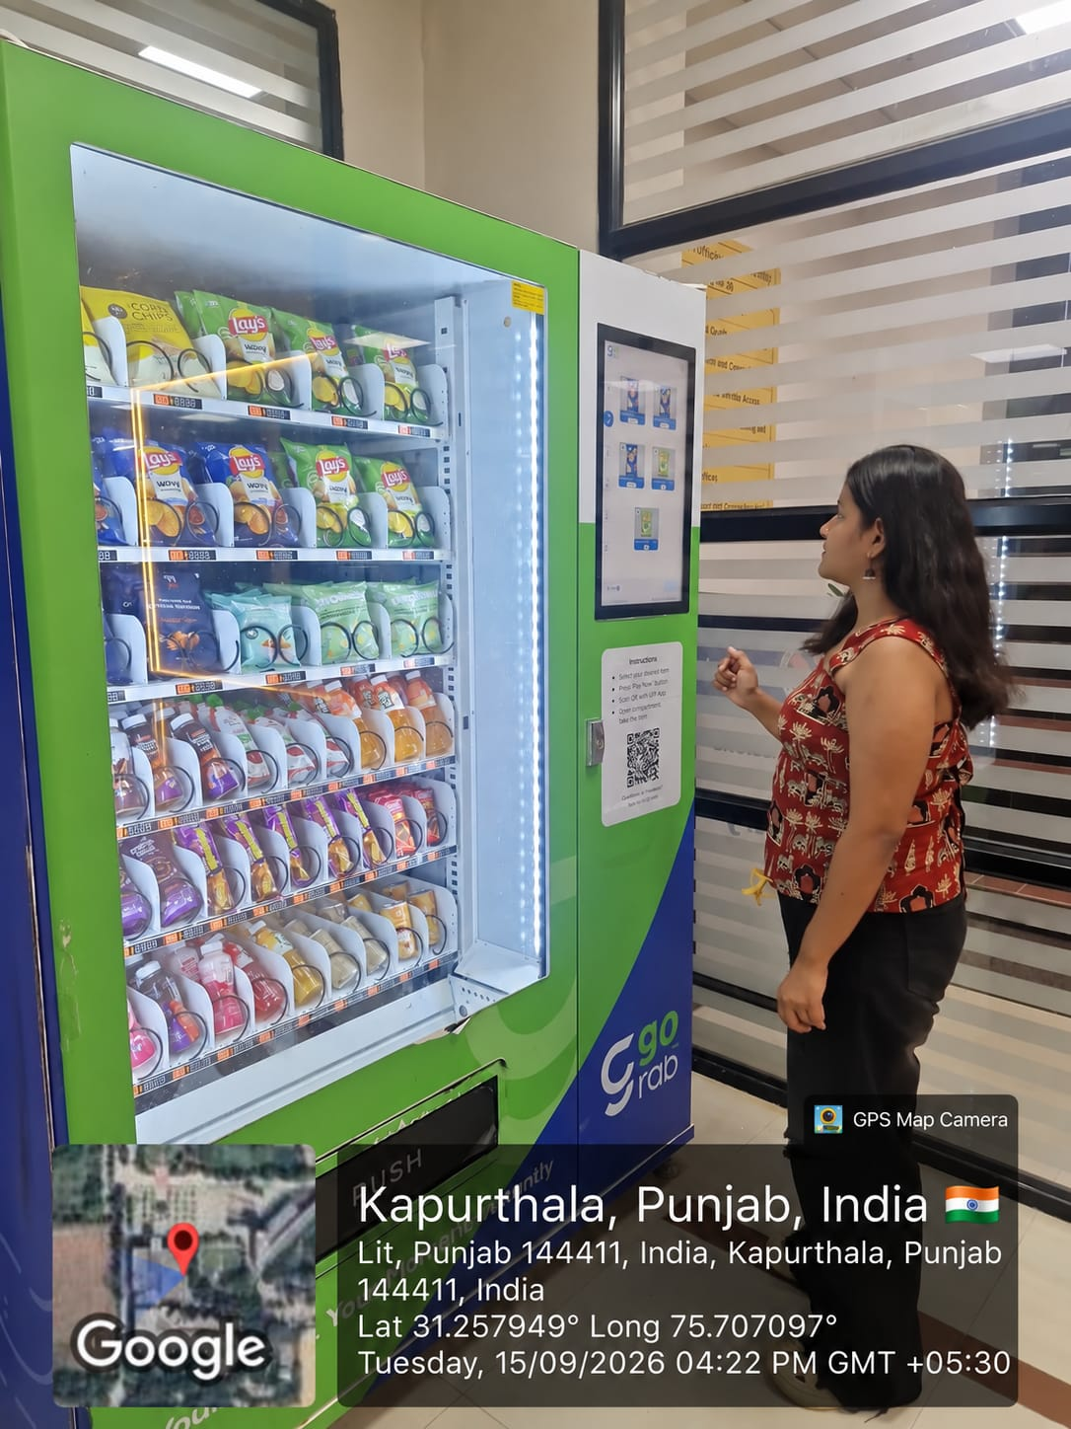
Photo 1: User interacting with the vending machine and touchscreen.
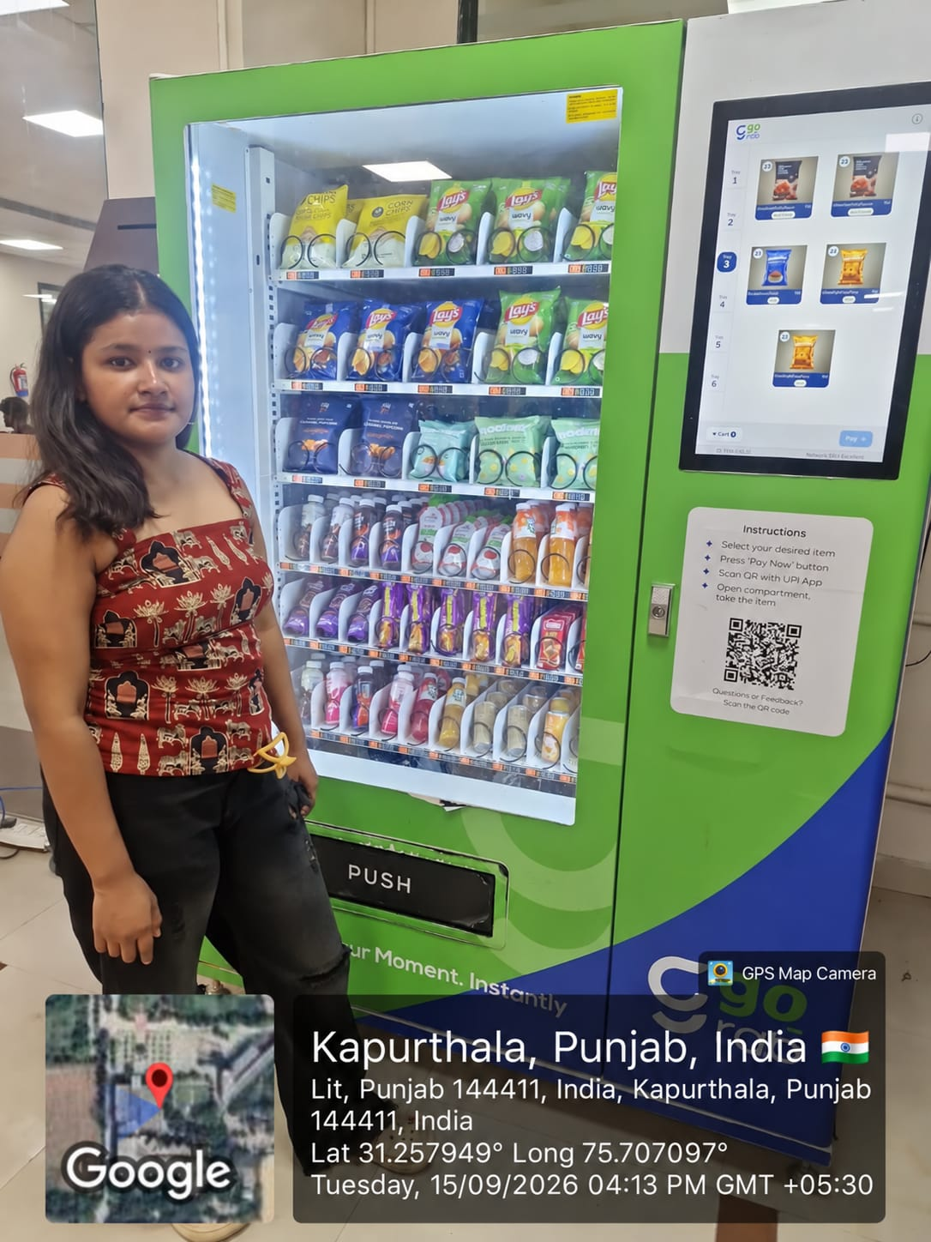
Photo 2: Front view showing the products, touchscreen, instructions, and collection area.

Machine 2: Interactive Touchscreen Machine
Machine Description:
The second selected equipment is a large touchscreen-based machine designed for providing digital information through an interactive display.
User Expectation:
The user expects the machine to clearly communicate its purpose and provide an obvious starting point for interaction. The available options and actions should be easy to identify.
User Behaviour:
- The user approached the touchscreen.
- The user examined the display to understand its purpose.
- The user looked at the screen before beginning the interaction.
- The user had to determine how to proceed from the available interface.
- The large touchscreen created an expectation of direct interaction.
Mental Model Mismatch:
The user expects a touchscreen-based machine to immediately provide clear interactive options. However, the initial interface does not make the available actions sufficiently obvious, creating uncertainty about how to begin.
Problem:
The main usability issue is poor discoverability. The user may not immediately understand the purpose of the machine or the first action required.
Improvement:
- Provide a clear initial interface that communicates the purpose of the machine.
- Use prominent navigation controls and interaction cues to make the available actions easier to identify.

Evidence:
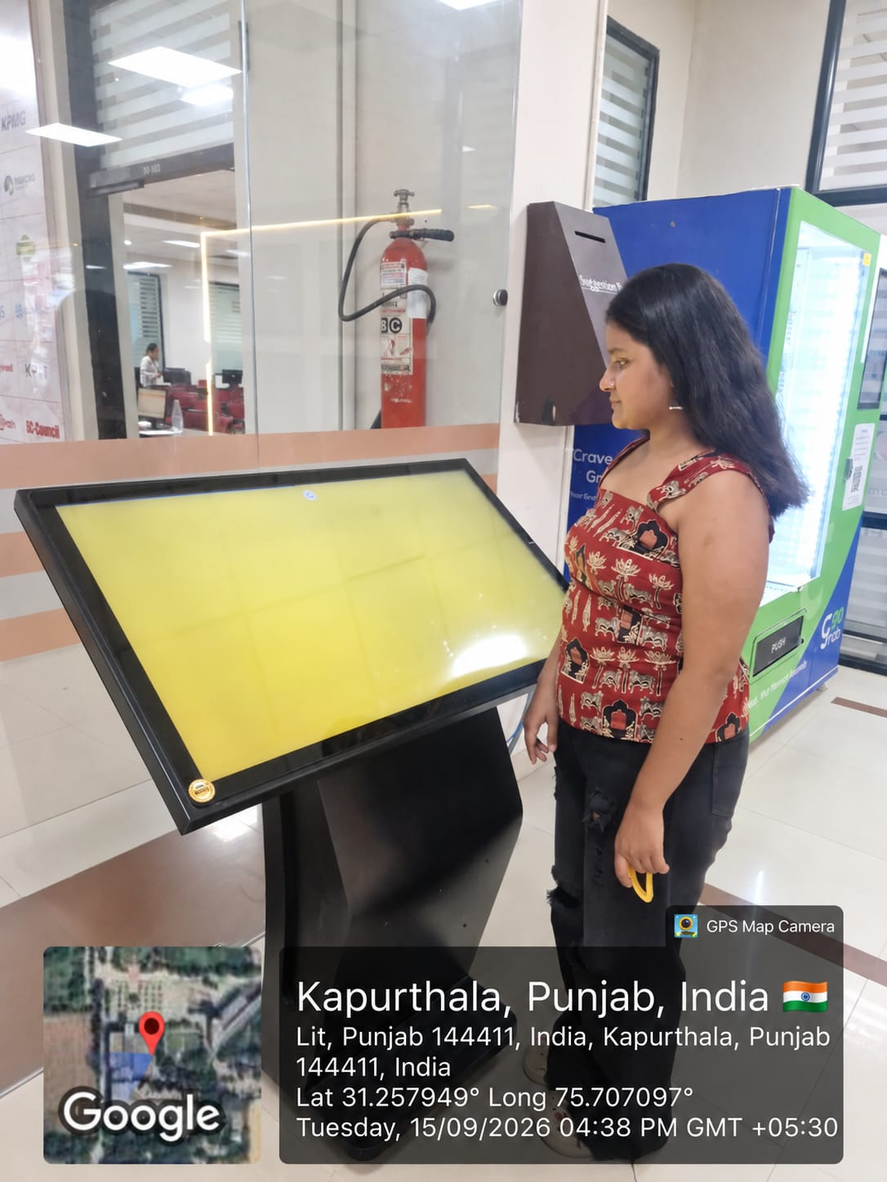
Photo 3: User standing beside the interactive touchscreen machine.

Comparative Analysis:
Aspect | Smart Vending Machine | Interactive Touchscreen Machine
Purpose | Automated product purchase | Digital information access
User Expectation | Easy product selection, payment and collection | Clear starting point and easy interaction
User Behaviour | Examined products, touchscreen and instructions | Examined the touchscreen to understand how to proceed
Mental Model Mismatch | Collection process differs from the expected vending-machine interaction | Starting point and available actions are not immediately clear
Usability Problem | Unclear product collection process | Poor discoverability
Improvement | Clear interaction flow and collection feedback | Clear initial interface and interaction cues

Key Findings:
- Users rely on their previous experiences when interacting with machines.
- Differences between expected and actual behaviour can cause hesitation and uncertainty.
- Physical and digital interaction elements should provide a consistent flow.
- Clear instructions and feedback can reduce user confusion.
- The first interaction should be immediately understandable.
Conclusion:
The study demonstrates the importance of designing machines according to the user's mental model. The smart vending machine presents a mismatch in the product collection process, while the interactive touchscreen machine presents a mismatch in discoverability and initial interaction.
Both machines can provide a more intuitive user experience through clear interaction flows, visible instructions, effective feedback, and easily identifiable controls.

